Infonique Drone

|  |  |  |
| --- | --- | --- |
| Prepared by | Date | Version |
| Bing Ran | 23/12/2023 | 1.0 |

# Abstract

This document provides detailed of Infonique expansion board specification.

# Document History

|  |  |  |  |
| --- | --- | --- | --- |
| **Date** | **Rev** | **Modifier** | **Changes** |
| **11-Nov-2021** | 1.0 | Bing Ran | First Draft |
|  |  |  |  |
|  |  |  |  |
|  |  |  |  |
|  |  |  |  |

# Contents

Abstract 2

Document History 2

Contents 3

Table of Figures 5

Table of table 6

1 Introduction 6

2 Understanding of Infonique Drone Controller 6

2.1 Joy Stick 8

2.1.1 Potentiometer of Joy stick 9

2.1.2 Skill Activities for potentionmeter of joy stick 10

2.1.3 Skill Activities for Input button of joy stick 12

2.2 LCD module 14

2.3 Buzzer 17

2.3.1 Skill activities of buzzer 18

2.4 RGB led 20

2.4.1 Skill activies of RGB Led 21

2.5 Wireless Radio frequency module 22

2.5.1 SPI Communication 24

2.5.2 Skill activities of Wireless Radio frequency module 24

3 Drone 27

3.1 Drone Main Board Pinout 28

3.2 Motor 29

3.2.1 Skill activities of PWM 32

3.3 Accelerator & gyro sensor MPU6050 Module 35

3.3.1 I2C communicaiton 36

3.3.2 Skill activies of MPU6050 37

3.4 Barometer BMP280 module 38

3.4.1 Skill activies of BMP280 40

3.4 GPS GT-U7 module 45

3.4.1 Universal Asynchronous Receiver-Transmitter ( UART ) 46

3.4.2 NEMA-0183 47

3.4.3 Skill activities on GT-U7 module 48

3.5.1 Skill activities on SD Card module 50

# Table of Figures

Figure 1: iSEB Drone Controller 7

Figure 2: Joy stick of Infonique Drone controller 8

Figure 3: A simple voltage divider. 9

Figure 4: Circuit of the detecting input buttons 9

Figure 5: Circuit of measuring the output of potentiometer 10

Figure 6: Figure 6: Circuit of detecting input buttons 12

Figure 7: LCD Module of Infonique Drone controller 14

Figure 8: Connection of LCD module with Arduino Uno of the iSEB Drone Controller 15

Figure 9: Pinout of LCD Module 15

Figure 10: Buzzer 17

Figure 11: RGB Led of Infonique Drone LED 20

Figure 12: SK68112mini 20

Figure 13: unipolar NRZ communications 21

Figure 14: Wireless RF transceiver module 22

Figure 15: RF24L01+ 2.4GHz module 22

Figure 16: Pinout of the RF24L01+ 2.4GHz module 23

Figure 17: Infonique Drone Pcb 27

Figure 18: SunnySky A2212 980KV Brushless Motors 29

Figure 19: Internal of a BLDC motor 29

Figure 20: Brushed DC motor 30

Figure 21: Skywaler 20A motor controller 30

Figure 22: Connection between motor and motor driver 31

Figure 23: Different duty cycle 31

Figure 24: Connection between LED and Arduino uno 32

*Figure 25: PWM and power connector* 33

Figure 26: MPU6050 module 35

Figure 27: Schematic of MPU6050 module 35

Figure 28: BMP280 module 38

Figure 29: Schematic of BMP280 module 39

Figure 30: GPS CT-U7 module 45

Figure 31: Serial vs Parallel Communication 46

Figure 32: SD Card module 50

Figure 33: 3S lithium battery 52

Figure 34: Battery charger 52

Figure 35: Battery voltage measuring circuit 53

# Table of table

Table 1: Connection table between Arduino UNO and LCD Module 14

Table 2: Connec*tion table between Arduino Uno and RF module* 22

Table 3 Expansion board pinout 27

Table 4: Connection table between Arduino UNO and MPU6050 Module 35

Table 5: Connection table between Arduino UNO and BMP280 Module 38

Table 6: Connection table between Arduino UNO and GPS Module 44

Table 7: NEMA-0183 message 46

Table 8: Interpretion of GGA 46

Table 9: Connection table between Arduino UNO and SD card Module 49

# 1 Introduction

Infonique Drone is an Arduino Uno based drone. The code used to build Infonique drone should be simple and understandable because the target audience will be student. There are two main part in infonique drone project which are Infonique drone and Infonique drone controller.

# 2 Understanding of Infonique Drone Controller

Infonique Drone Controller is to control Infonique Drone from a distance through radio frequency.The figure below is showing the the snapshot of infonique Drone controller.

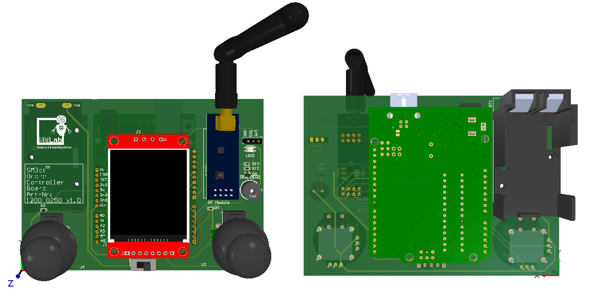Figure 1: iSEB Drone Controller

The components in the iSEB Drone controller are in the following list

* 2 Joy sticks
* 1.8 inches LCD module
* RF module
* RGB led
* Buzzer

## 2.1 Joy Stick

The figure below is showing the joy stick of Infonique Drone controller.

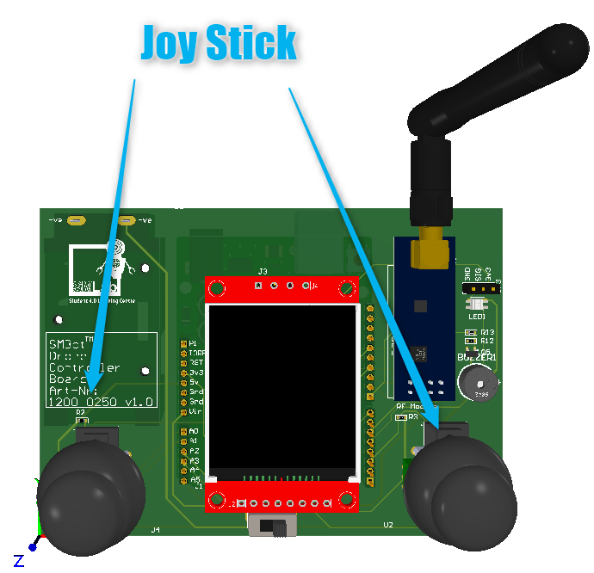Figure 2: Joy stick of Infonique Drone controller

### 2.1.1 Potentiometer of Joy stick

Joystick consist of 2 axis which ar X-axis and Y-axis. Both of them have their own potentiometer.The output of the potentiometer will be connected to Arduino Uno analog input.For Infoniue Drone controller the Vin will be connected to 5v and Vout ( output of X-axis and Y-axis potentiometer ) wll be connect to analog pin. The Joy stick working principle is voltage divider rule.

Vout = Vin * ( R2 / R1+R2 ) .

Voltage divider rule is working base on Ohm’s Law.

Voltage(V) = Current(I) * Resistance(R)

The following snapshot is a simple voltage divider snapshot.

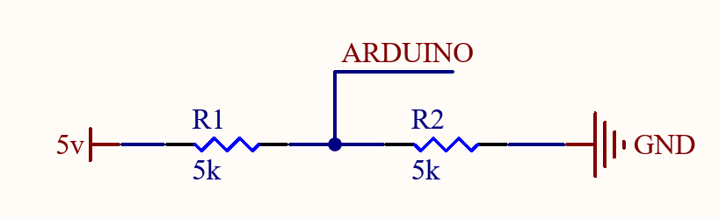

Figure 3: A simple voltage divider.

In the non-operating mode , the potentiometer is in the middle hence R1 = R2. Base on the voltage divider rule the Vout will be Vin * ( R2 / R1 + R2 ) which is 5v * ( 5kΩ / (5kΩ + 5kΩ ) = 2.5v

If one of the axis changes, like the x-axis for exmple , the values of the resistors will change -e.g. value of R1 will raise and value of R2 will fall or vice versa.

According to the division of the resistor values , you can mesaure a specific voltage value between the resistors and locate the position of the axis.

2.1.2 Button of the joy stick

Joystick consists one 1 button. We will receive 0v when we press the button and 5v when we release the button. We able to detect the press or release of the button through the circuit below

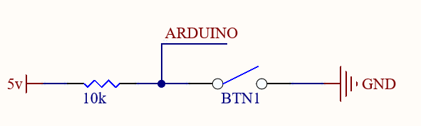Figure 4: Circuit of the detecting input buttons

### 2.1.2 Skill Activities for potentionmeter of joy stick

Objective : To learn how to read potentionmeter with ardiuno uno.

Tools : ThinkerCad

Link : https://www.tinkercad.com/things/cn1nkCoP36z-potentiometer/editel?returnTo=%2Fdashboard&sharecode=HCKdmq5neVAbsTGDUd896sD_kIUrVUSXAzStYKhgfmk

We able to measure the output of the potentiometer with the circuit below

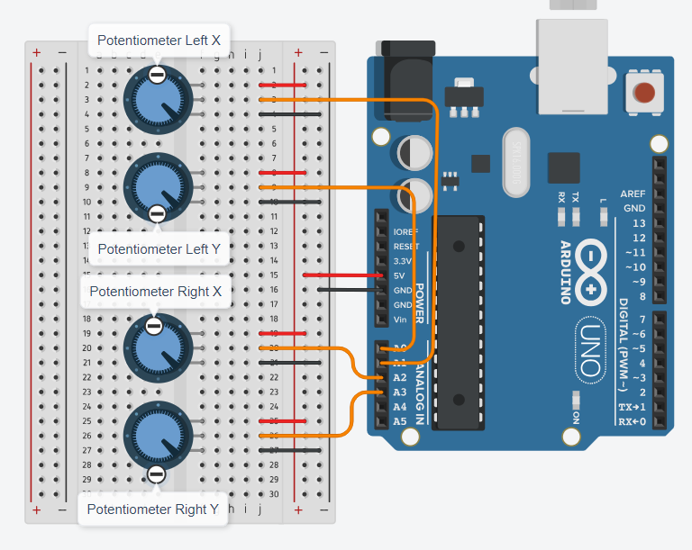Figure 5: Circuit of measuring the output of potentiometer

The following is the example code of measuring output of the potentiometer of iSEB Drone Controller:

/* Pinout Definition */

#define rightYPin   A3

#define rightXPin   A2

#define leftYPin    A1

#define leftXePin   A0

/* status of the potentiometer */

float flLeftX = 0;

float flLeftY = 0;

float flRightX = 0;

float flRightY = 0;

/* Period of checking the status of the potentiometer */

int timeout = 500;

void setup() {

  /* Serial */

  Serial.begin(115200);

  Serial.println("Hello World!");

}

void loop() {

  // put your main code here, to run repeatedly:

   delay(1);

  if(0 != timeout)

  {

    timeout--;

    if(0 == timeout)

    {

      timeout = 1000;

      flLeftX = analogRead(leftXePin);

      flLeftY = analogRead(leftYPin);

      flRightX = analogRead(rightXPin);

      flRightY = analogRead(rightYPin);

      Serial.print((flLeftX));

      Serial.print(" | ");

      Serial.print((flLeftY));

      Serial.print(" | ");

      Serial.print((flRightX));

      Serial.print(" | ");

      Serial.println((flRightY));

    }

  }

}

### 2.1.3 Skill Activities for Input button of joy stick

Objective : To learn how to detect input switch with arduino uno.

Tools : ThinkerCad

Link : https://www.tinkercad.com/things/f6lbDtcywoc-input-button/editel?returnTo=%2Fdashboard%3Ftype%3Dcircuits%26collection%3Ddesigns&sharecode=8Z39IKQlJCucofDh1ZdKiuYOpfo1JErqy8fl07NxP2w

Joystick consists one 1 button. We will receive 0v when we press the button and 5v when we release the button. We able to detect the press or release of the button through the circuit below

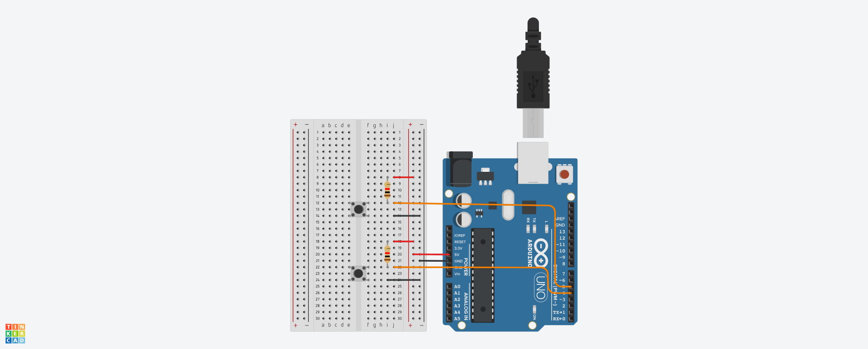

Figure 6: Figure 6: Circuit of detecting input buttons

The following is the example code of detecting input button of iSEB Drone Controller:

/* Pinout Definition */

#define leftButtonPin 5

#define rightButtonPin 4

/* state of buttons */

bool bRightButton = false;

bool bLeftButton = false;

void setup() {

  /* Serial */

  Serial.begin(115200);

  Serial.println("Hello World!");

}

void loop() {

  /* Detect change state of left button */

  if (bLeftButton != digitalRead(leftButtonPin)) {

    bLeftButton = digitalRead(leftButtonPin);

    if (0 == bLeftButton) {

      Serial.println("Left button is pressed");

    } else {

      Serial.println("Left button is released");

    }

  }

  /* Detect change state of right button */

  if (bRightButton != digitalRead(rightButtonPin)) {

    bRightButton = digitalRead(rightButtonPin);

    if (0 == bRightButton) {

      Serial.println("Right button is pressed");

    } else {

      Serial.println("Right button is released");

    }

  }

}

## 2.2 LCD module

The figure below is showing the LCD module of Infonique Drone controller.

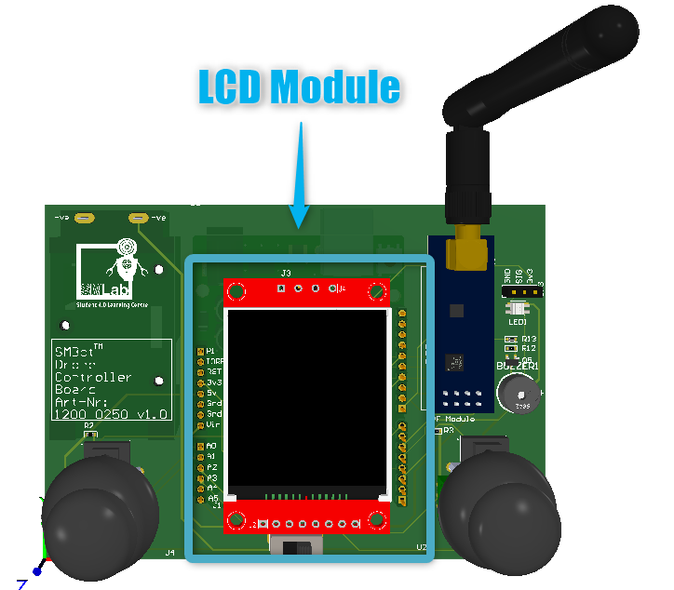Figure 7: LCD Module of Infonique Drone controller

The Infonique Drone controller is using 1.8 TFT display module as the LCD module. The input voltage range of the LCD module is 3.3v to 5v. Voltage exceed 5v will damge the LCD module. LCD module is JD-T18003-T01 as LCD panel with Sitronix ST7735 as driver IC . It has 128 x 160 display resolution.

The LCD panel of the LCD module has a liquid crystal layer between the substrate and the pixel electrode. When the change of the voltage is applied to the liquid crystal, it changes the transmittance of panels. Thus, changes the quantity of light from the backlight. As a result, LCD generates full-color images.

We able to control the LCD module with SPI communication.c

The following is showing the connection between LCD module and Arduino uno of the iSEB Drone Controller.

Figure 8: Connection of LCD module with Arduino Uno of the iSEB Drone Controller

The following is the connection table between Arduino Uno and LCD module

|  |  |
| --- | --- |
| Arduino | LCD Module |
| 3.3v | Connect with a 1kΩ Resistor |
| 13 | SCK |
| 11 | SDA |
| A5 | A0 |
| A4 | RESET |
| 7 | CS |
| GND | GND |

Table 1: Connection table between Arduino UNO and LCD Module

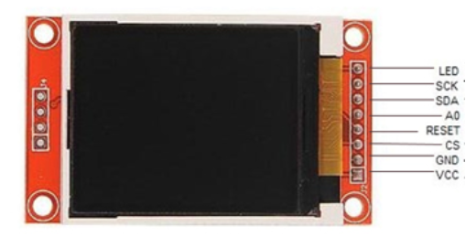Figure 9: Pinout of LCD Module

2.2.1 Skill activities of LCD module

Objecttve : To learn how to control LCD module with arduino uno.

Tools : Arduino UNO , SMBot Drone Controller Board and LCD module

Steps:

* Connect LCD module to SMBost Drone Controller Board
* Connect SMBot Drone Controller Board to Ardruino
* Program the Arduino with the following code with arduino IDE
* Ensure Arduino IDE should have Adafruit_GFX and Adafruit_ST7735 library installed.

The following is the example code of communicate with LCD module of iSEB Drone Controller:

#include <Adafruit_GFX.h>    // Core graphics library

#include <Adafruit_ST7735.h> // Hardware-specific library for ST7735

#include <stdint.h>

/* Pinout Definition */

#define tftCsPin  7

#define tftDcPin    A5

#define tftRstPin   A4 // Or set to -1 and connect to Arduino RESET pin

uint16_t        Display_Text_Color         = 0x0000;

uint16_t        Display_Backround_Color    = 0xFFFF;

Adafruit_ST7735 tft = Adafruit_ST7735(tftCsPin, tftDcPin, tftRstPin);

void setup() {

  /* Serial */

  Serial.begin(115200);

  Serial.println("Hello World!");

  // Init ST7735S chip, black tab

  tft.initR(INITR_BLACKTAB);

  // initialise the display

  tft.setFont();

  tft.fillScreen(Display_Backround_Color);

  tft.setTextColor(Display_Text_Color);

  tft.setTextSize(2);

  tft.setCursor(5,5);

  tft.print("Hello");

  tft.setCursor(5,25);

  tft.print("World!");

}

void loop() {

}

## 2.3 Buzzer

The figure below is showing the buzzer of Infonique Drone controller.

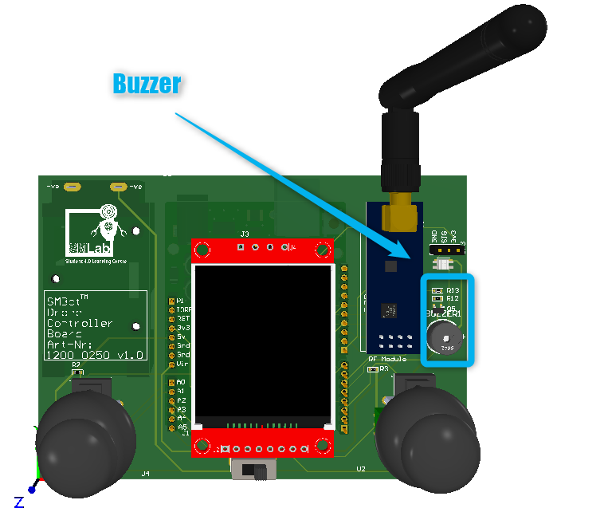Figure 10: Buzzer

The buzzer of infonique drone controller is a piezo buzzer. Piezo buzzer are constructed by placing electrical contacts on the two faces of a disk of piezoelectric material and then supporting the disk at the edges in an enclosure. When a voltage is applied accorss the two electrodes, the piezoelectric material mechanically deforms due to the applied voltage. This movement of the piezo disk within the buzzer will creates sound.

We able to produce sound at different pitch by providing different frequency of the signal to the buzzer.There is a ready library in arduino libarary that we can produrce different tone with piezo buzzer which is Tone. Tone is one of the basic library of arduino uno. The details of the library can refer to the the following link : https://www.arduino.cc/reference/en/language/functions/advanced-io/tone/

### 2.3.1 Skill activities of buzzer

Objective : To learn how to sound the buzzer at different tone.

Tools : ThinkerCad

Link : https://www.tinkercad.com/things/0IOfuCL3NyK-buzzer/editel?returnTo=%2Fdashboard%3Fcollection%3Ddesigns%26type%3Dcircuits&sharecode=EosjgOnIb7Fxx4TRuogBBDe8Bd3uwV5PJx9164v-Jc4

The following is showing the connection between Buzzer and Arduino uno of the iSEB Drone Controller.

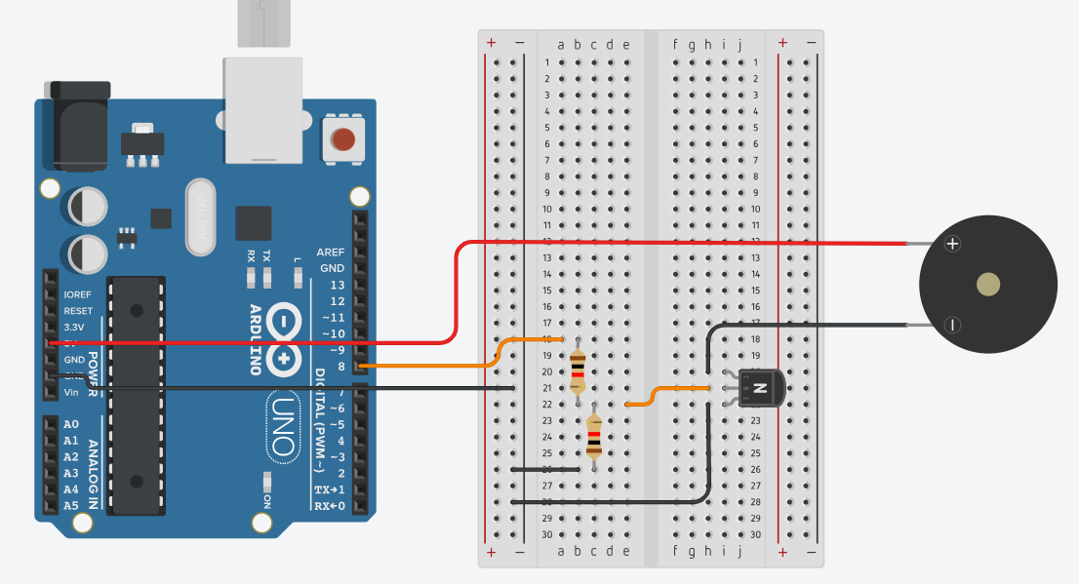The following is the example code of playing tone with buzzer of iSEB Drone Controller

#include "pitch.h"

// change this to make the song slower or faster

int tempo = 280;

// change this to whichever pin you want to use

int buzzer = 8;

// notes of the moledy followed by the duration.

// a 4 means a quarter note, 8 an eighteenth , 16 sixteenth, so on

// !!negative numbers are used to represent dotted notes,

// so -4 means a dotted quarter note, that is, a quarter plus an eighteenth!!

int melody[] = {

  // Happy Birthday

  NOTE_C4,4, NOTE_C4,8,

  NOTE_D4,-4, NOTE_C4,-4, NOTE_F4,-4,

  NOTE_E4,-2, NOTE_C4,4, NOTE_C4,8,

  NOTE_D4,-4, NOTE_C4,-4, NOTE_G4,-4,

  NOTE_F4,-2, NOTE_C4,4, NOTE_C4,8,

  NOTE_C5,-4, NOTE_A4,-4, NOTE_F4,-4,

  NOTE_E4,-4, NOTE_D4,-4, NOTE_AS4,4, NOTE_AS4,8,

  NOTE_A4,-4, NOTE_F4,-4, NOTE_G4,-4,

  NOTE_F4,-2,

};

// sizeof gives the number of bytes, each int value is composed of two bytes (16 bits)

// there are two values per note (pitch and duration), so for each note there are four bytes

int notes = sizeof(melody) / sizeof(melody[0]) / 2;

// this calculates the duration of a whole note in ms

int wholenote = (60000 * 4) / tempo;

int divider = 0, noteDuration = 0;

void setup() {

  // iterate over the notes of the melody.

  // Remember, the array is twice the number of notes (notes + durations)

  for (int thisNote = 0; thisNote < notes * 2; thisNote = thisNote + 2) {

    // calculates the duration of each note

    divider = melody[thisNote + 1];

    if (divider > 0) {

      // regular note, just proceed

      noteDuration = (wholenote) / divider;

    } else if (divider < 0) {

      // dotted notes are represented with negative durations!!

      noteDuration = (wholenote) / abs(divider);

      noteDuration *= 1.5; // increases the duration in half for dotted notes

    }

    // we only play the note for 90% of the duration, leaving 10% as a pause

    tone(buzzer, melody[thisNote], noteDuration * 0.9);

    // Wait for the specief duration before playing the next note.

    delay(noteDuration);

    // stop the waveform generation before the next note.

    noTone(buzzer);

  }

}

void loop() {

  // no need to repeat the melody.

}

## 2.4 RGB led

The figure below is showing the RGB Led of Infonique Drone controller.

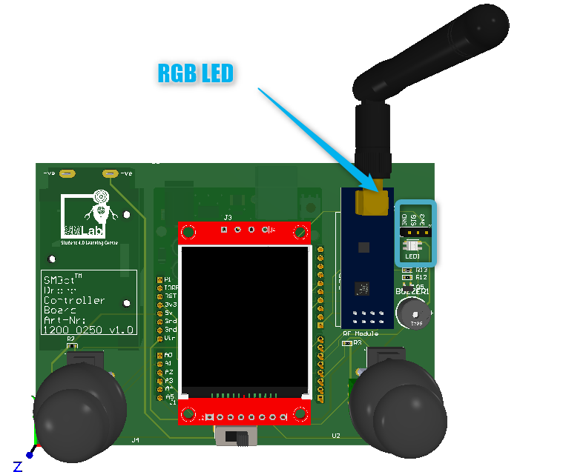Figure 11: RGB Led of Infonique Drone LED

The RGB led of Infonique Drone controller is SK6812mini. The figure below is showing the snap shot of SK6812mini led.

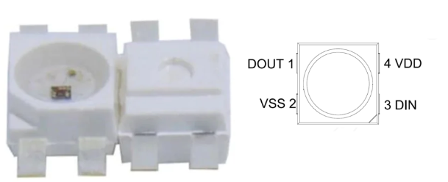Figure 12: SK68112mini

SK6812mini is a smart LED control circuit and light emitting circuit in one controlled LED source. We able to control the SK6821mini with unipolar NRZ communication mode. The 24-bit data is transmitted from the controller to DIN of the first element, and if it is accepted it is extracted pixel to pixel. After an internal data latch, the remaining data is passed through the internal amplification circuit and sent out on the DO port to the remaining pixels. The pixel is reset after the end of DIN.

The following snapshot is showing example of unipolar NRZ communications

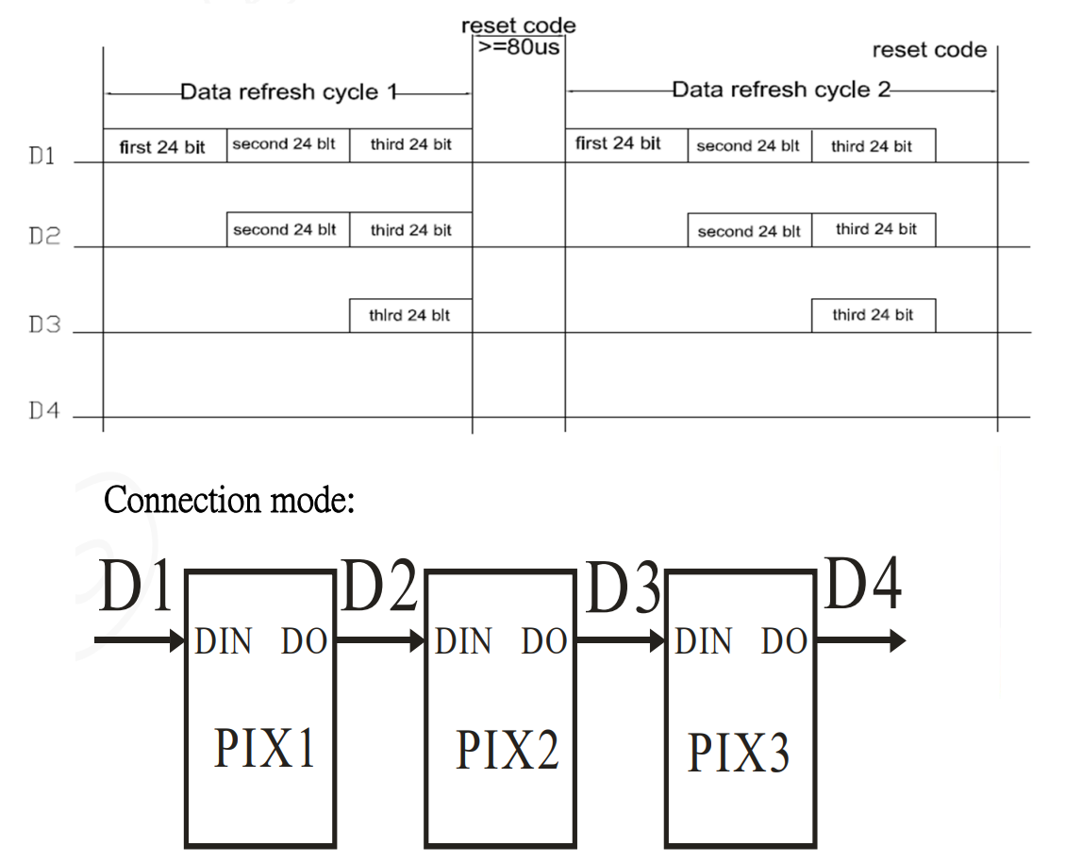Figure 13: unipolar NRZ communications

### 2.4.1 Skill activies of RGB Led

Objective : To learn how to control SK6812mini with arduino uno

Tools : Arduino UNO and SMBot Drone Controller Board

Steps:

* Connect SMBot Drone Controller Board to Ardruino
* Program the Arduino with the following code with arduino IDE
* Ensure Arduino IDE should have WS2812FX library installed.

For the Infonique Drone controller , we will be using D4 to control the RGB LED and the following is the example code of controlling the output of RGB LED

#include <WS2812FX.h>

/* Pinout Definition */

#define rgbledPin 4

WS2812FX ws2812fx = WS2812FX(1, rgbledPin, NEO_GRB + NEO_KHZ800);

void setup() {

  // put your setup code here, to run once:

  ws2812fx.init();

  ws2812fx.setBrightness(1);

  ws2812fx.setSegment(0, 0,1, FX_MODE_SINGLE_DYNAMIC,  RED, 200, false);

  ws2812fx.start();

}

void loop() {

  // put your main code here, to run repeatedly:

  ws2812fx.service();

}

## 2.5 Wireless Radio frequency module

The figure below is showing the Wirelss RF module of Infonique Drone controller.

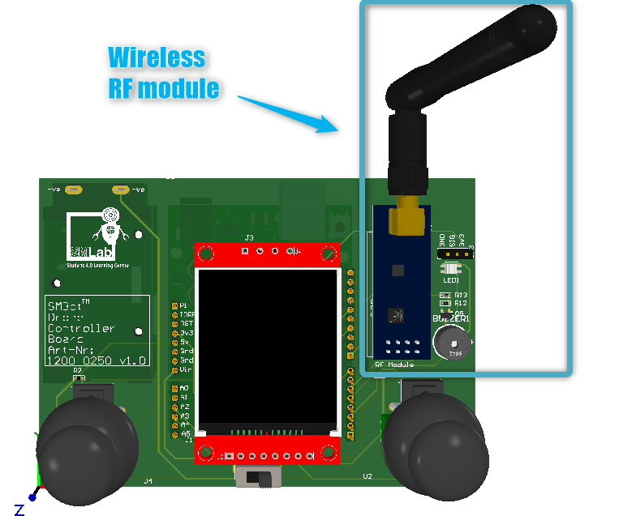Figure 14: Wireless RF transceiver module

The Wireless Radio frequency module of Infonique Drone controller is RF24L01+ module. The following figure is showing the RF24L01+ 2.4GHz module

The following figure is showing the pinout of the RF24L01+ module

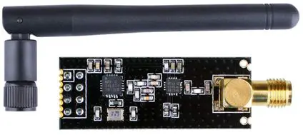

Figure 15: RF24L01+ 2.4GHz module

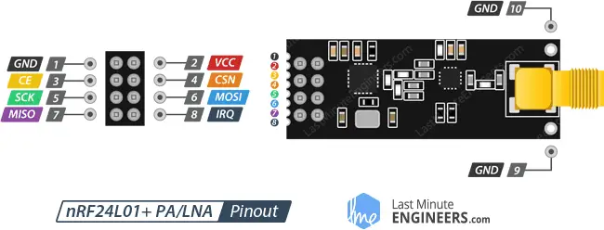

Figure 16: Pinout of the RF24L01+ 2.4GHz module

The following is the connection table between Arduino Uno and RF module

|  |  |
| --- | --- |
| Arduino | LCD Module |
| GND | GND |
| 3.3v | VCC |
| D9 | CE |
| D10 | CSN |
| D13 | SCK |
| D11 | MOSI |
| D12 | MISO |
| D5 | IRQ |

Table 2: Connec*tion table between Arduino Uno and RF module*

We able to communicate with the RF24L01+ 2.4GHz module with SPI communication.There is a ready library in arduino libarary that we can apply to communicate with RF24L01+ 2.4GHz module. The details of the RF24 library can refer to the following link: https://nRF24.github.io/RF24

We the pin D12 and D13 are sharing with LCD module.This is bec ause SPI can be set up to operate with a single master and multiple slaves.

### 2.5.1 SPI Communication

SPI is a common communication protocol used by many different devices. For example,SD card module , LCD module and 2.4GHz wireless modulel use SPI to communicate with microcontrollers.

One unique benefit of SPI is the fact that data can be transferred without interruption. Any number of bits can be sent or received in a continuous stream. With I2C and UART, data is sent in packets, limited to a specific number of bits. Start and stop conditions define the beginning and end of each packet, so the data is interrupted during transmission.

Devices communicating via SPI are in a master-slave relationship. The master is the controlling device (usually a microcontroller), while the slave (usually a sensor, display, or memory chip) takes instruction from the master. The simplest configuration of SPI is a single master, single slave system, but one master can control more than one slave.There is 4 interface which is

* **MOSI (Master Output/Slave Input)** – Line for the master to send data to the slave.
* **MISO (Master Input/Slave Output)** – Line for the slave to send data to the master.
* **SCLK (Clock)** – Line for the clock signal.
* **SS/CS (Slave Select/Chip Select)** – Line for the master to select which slave to send data to.

For MOSI and MISO , the master will send data to slave bit by sit, in serial through MOSI line. The slave receives the data sent from the master at the MOSI pin. Data sent from master to the slave is usually sent with the most significant bit first.The slave can also send data back to master through MISO line in serial. The data sent from the slave back to the master is usually sent with the least significant bit first.

For clock signal of SPI synchronizes the output of data bits from the master to the sampling of bits by the slave. One bit of data is transferred in each clock cycle, so the speed of data transfer is detemined byb the frequency of the clock signal. Since master is configuring and generating the clock signal, SPI commmunication is always initiated by the master. SPI is a synchronous communication protocl. Any communication protocol where devices share a clock signal is known as synchronous.

For the SS/CS ( slave select/ chip select ) , the master can choose which slave it wants to talk to by setting the slaves’s CS/SS line to a low voltage level. The slave select line is kept at high voltage level during idle/non-transmitting state. Multpile CS/SS pin will allow a single master to communicate with multiple slave in a SPI bus.

### 2.5.2 Skill activities of Wireless Radio frequency module

Objective :

* To learn how to control wireless raodio frequency module.
* To experience how wireless communication.

Tools: 2x Arduino UNO , SMBot Drone Controller Board and wireless radio frequency module

Steps:

* Connect LCD module to SMBost Drone Controller Board
* Connect SMBot Drone Controller Board to Ardruino to Ardruino uno.
* Program the Arduino with the following code with Arduino IDE .
* Ensure Arduino IDE should have RF24.h library is installed.
* Both wireless radio frequency module should be able to communicate.

For the Infonique Drone controller , we will be using D7 as Chip Enable CE PIN and D10 as Chip select not CSN Pin. We will need 2 set of the device one act as transmitter another act as receiver.

The following the example code for transmitter

///Include Libraries

#include <SPI.h>

#include <nRF24L01.h>

#include <RF24.h>

//create an RF24 object

RF24 radio(7, 10); // CE, CSN

//address through which two modules communicate.

const byte address[6] = "00001";

void setup()

{

radio.begin();

//set the address

radio.openWritingPipe(address);

//Set module as transmitter

radio.stopListening();

}

void loop()

{

//Send message to receiver

const char text[] = "Hello World";

radio.write(&text, sizeof(text));

delay(1000);

}

The following the example code for Receiver

//Include Libraries

#include <SPI.h>

#include <nRF24L01.h>

#include <RF24.h>

//create an RF24 object

RF24 radio(9, 8); // CE, CSN

//address through which two modules communicate.

const byte address[6] = "00001";

void setup()

{

while (!Serial);

Serial.begin(9600);

radio.begin();

//set the address

radio.openReadingPipe(0, address);

//Set module as receiver

radio.startListening();

}

void loop()

{

//Read the data if available in buffer

if (radio.available())

{

char text[32] = {0};

radio.read(&text, sizeof(text));

Serial.println(text);

}

}

# 3 Drone

Drone main board is designed to control the Infonique drone. The drone main board has to be used with an Arduino Uno or Mega. The features that can be provided by the drone main board are listed below:

* Control the speed of 4 motors.
* Able to measure atmospheric pressure, temperature and humidity.
* Able to measure the vibration or acceleration of motion of a structure.
* Able to harness the principle of conservation of angular momentum.
* Able to measure the voltage of the battery.
* Able to communicate with radio frequency devices at 2.4 GHz ISM band.
* Able to communicate with Bluetooth devices.
* Able to measure distance with an object.
* Able to do data logging.

However, some of the features that might not work as expected when using Arduino UNO, such as Bluetooth and distance measuring, are due to the limitations of Arduino UNO. The figure below shows the top and back of the Drone main board. It is 13cm x 13cm .

Figure 17: Infonique Drone Pcb

## 3.1 Drone Main Board Pinout

|  |  |  |  |
| --- | --- | --- | --- |
| Pin | Function | Pin | Function |
| D0 | UART Rx | D13 | SPI Clock |
| D1 | UART Tx | D14 | Bluetooth Tx |
| D2 | SD card chip select | D15 | Bluetooth Rx |
| D3 | Motor3 PWM | A0 | Radio frequency chip enable |
| D4 | GPS Tx | A1 | Radio frequency interrupt request |
| D5 | Motor2 PWM | A2 | Ultrasonic Trigger |
| D6 | Motor4 PWM | A3 | ADC Battery |
| D7 | GPS Rx | A4 | I2C SDA |
| D8 | Buzzer | A5 | I2C SCL |
| D9 | Motor1 PWM | A6 | Ultrasonic Echo1 |
| D10 | Radio frequency chip select not | A7 | Ultrasonic Echo2 |
| D11 | SPI MOSI | A8 | Ultrasonic Echo3 |
| D12 | SPI MISO | A9 | Ultrasonic Echo4 |

Table 3 Expansion board pinout

*Pinouts that weren't mentioned are not in use.

## 3.2 Motor

Infonique Drone is using brushless DC motor which are SunnySky A2212 980KV Brushless Motors. The image below is showing the figure of SunnySky A2212 980KV Brushless Motors

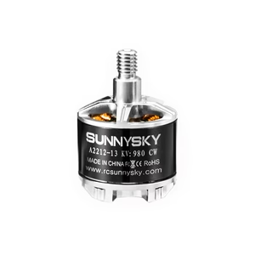Figure 18: SunnySky A2212 980KV Brushless Motors

There are several advantages of BLDC motors

* Better engergy efficiency
* Higher starting torque
* Higher RPM
* Longer lifespan

The figure below is showing the component of the internal of a BLDC motor

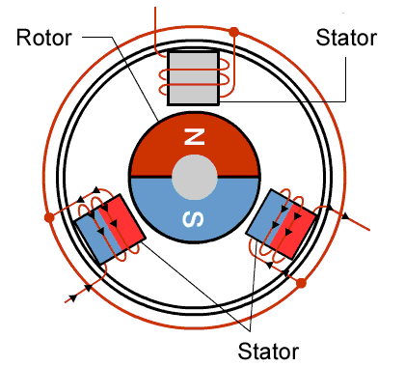Figure 19: Internal of a BLDC motor

As their name implies, brushless DC motors do not use brushes which is different from brushed motor. The following figure is showing a brushed DC motor.

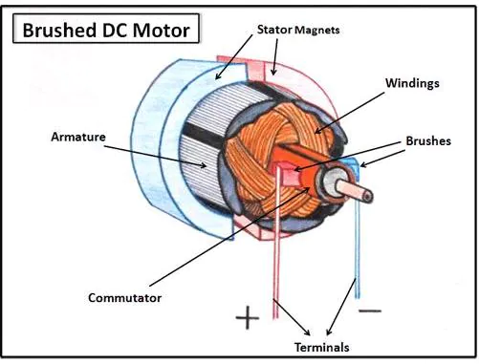Figure 20: Brushed DC motor

For BLDC motor , the rotor is a permanant magnet, it needs no current, elimating the need for brushes and commutator. We can control the direction and speed of the BLDC motor by adjust the magnitude and direction of the current into the BLDC motor coils ( U,V & W ). Hence,We need a motor driver to drive it. The motor driver is that used by Infonique Drone is Skywalker 20A Motor Controller which is showing below.

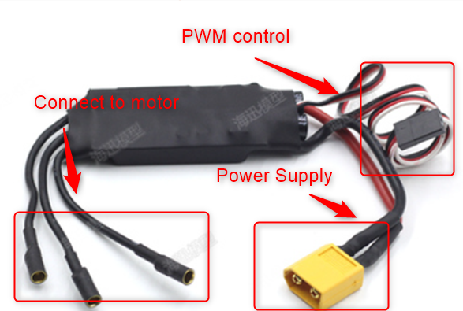Figure 21: Skywaler 20A motor controller

The figure below is showing the connection between

We able to use PWM to control the motor driver. We are using pin 3 ,5 ,6 and 9 to output PWM at 50 Hz and control the speed of the motor with duty cyle withint 10% to 20%.

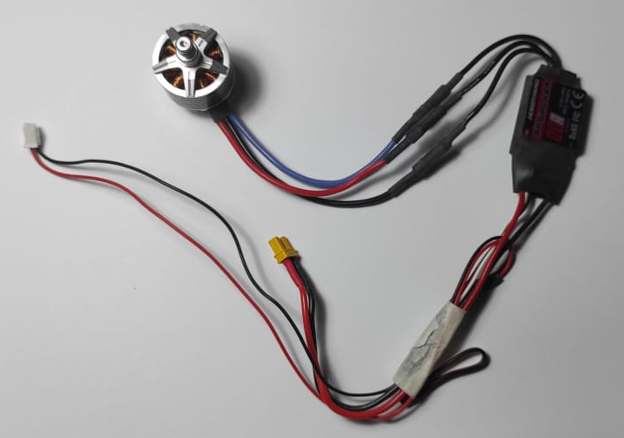Figure 22: Connection between motor and motor driver

Pulse width modulation (PWM) is a technique for controlling analog circuits with microcontroller’s digital outputs. There are two parameter in PWM which are frequency and dutry cycle. Frequency is measure in hertz (Hz), it is the number of occurrences of a repeating event per unit of time (f = 1/T). Malaysia power grid is at 240v 50Hz. Duty cycle is the ratio of time a load. The following the is the figure of different duty cycle.

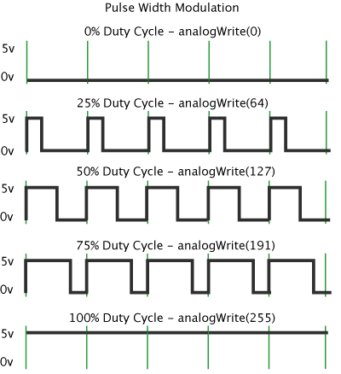Figure 23: Different duty cycle

### 3.2.1 Skill activities of PWM

Objective : To experience how PWM works

Tools : ThinkerCad

Link : <https://www.tinkercad.com/things/hvNZXNoAjk5-bodacious-sango-juttuli/editel?sharecode=45Z5Wz6BpW-HLaHJzQFAB9nu1Lnm7u9OwIPmVNBVOrk>

The following is showing the connection between LED and Arduino uno

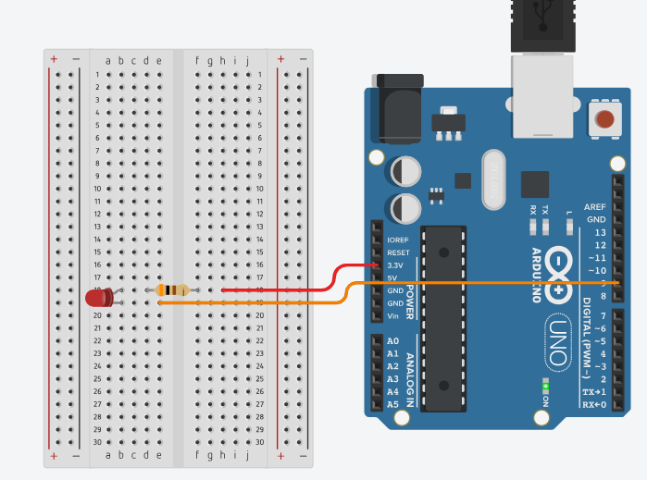Figure 24: Connection between LED and Arduino uno

The following is the example code for output pwm to control the brightness of led.

uint8_t count = 0 ;

uint8_t flag = 0;

void setup()

{

  pinMode(9, OUTPUT);

}

void loop()

{

  delay(10);

  if(count == 255||count == 0) {

    flag = !flag;

  }

  if(1 == flag){

    analogWrite(9,count++);

  }

  else  {

    analogWrite(9,count--);

  }

}

3.2.2 Skill activities of Motor

Objective : To experience how PWM control motor

Tools : Arduino uno, SMBot Drone Board , motor driver and motor.

Steps:

* Connect SMBot Drone Board to Ardruino uno.
* Connect power and PWM connector of motor driver to SMBot Drone Board.
* Connect motor driver to motor as shown in figure 22.
* Program the Arduino with the following code with Arduino IDE .
* Ensure Arduino IDE should have Servo.h library is installed.
* Motor will move accordingly.

The figure following showing the PWM and power connector of SMBot Drone board

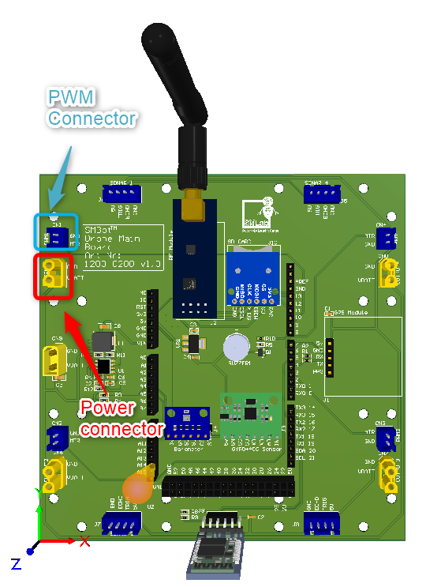

*Figure 25: PWM and power connector*

The following is the example code for controlling motor

#include <Servo.h>

// ---------------------------------------------------------------------------

// Customize here pulse lengths as needed

#define MIN_PULSE_LENGTH 1000 // Minimum pulse length in µs

#define MAX_PULSE_LENGTH 5000 // Maximum pulse length in µs

// ---------------------------------------------------------------------------

Servo motA;

char data;

// ---------------------------------------------------------------------------

/**

 * Initialisation routine

 */

void setup() {

    Serial.begin(9600);

    motA.attach(9, MIN_PULSE_LENGTH, MAX_PULSE_LENGTH);

    motA.writeMicroseconds(MIN_PULSE_LENGTH);

    displayInstructions();

}

/**

 * Main function

 */

void loop() {

    if (Serial.available()) {

        data = Serial.read();

        switch (data) {

            // 0

            case 48 : Serial.println("Sending minimum throttle");

                      motA.writeMicroseconds(MIN_PULSE_LENGTH);

            break;

            // 1

            case 49 : Serial.println("Sending maximum throttle");

                      motA.writeMicroseconds(MAX_PULSE_LENGTH);

            break;

            // 2

            case 50 : Serial.print("Running test in 3");

                      delay(1000);

                      Serial.print(" 2");

                      delay(1000);

                      Serial.println(" 1...");

                      delay(1000);

                      test();

            break;

        }

    }

}

void test()

{

    for (int i = MIN_PULSE_LENGTH; i <= MAX_PULSE_LENGTH; i += 5) {

        Serial.print("Pulse length = ");

        Serial.println(i);

        motA.writeMicroseconds(i);

        if (Serial.available()) {

          break;

        }

        delay(200);

    }

    Serial.println("STOP");

    motA.writeMicroseconds(MIN_PULSE_LENGTH);

}

/**

 * Displays instructions to user

 */

void displayInstructions()

{

    Serial.println("READY - PLEASE SEND INSTRUCTIONS AS FOLLOWING :");

    Serial.println("\t0 : Send min throttle");

    Serial.println("\t1 : Send max throttle");

    Serial.println("\t2 : Run test function\n");

}

## 3.3 Accelerator & gyro sensor MPU6050 Module

There is a accelertaor & gyro sensor on Infonique Drone which is MPU6050 module. The following figure is showing the MPU6050 module in the Infonique Drone.

MPU6050 module has both 3-Axis accelerometer and 3-Axis gyroscope intergrated on a ship chip. The gyroscope measure rotational velocit or rate of change of the angular position over time, along the X,Y and Z axis. The output os the gyroscope are in degrees per second. The acceletometer measures acceleration, It can measure graviational acceleration along the 3 axes. With the combine the accelerometer and gyroscope data , we can get information about the sensor orientation. The following is the schematic of the MPU6050 module

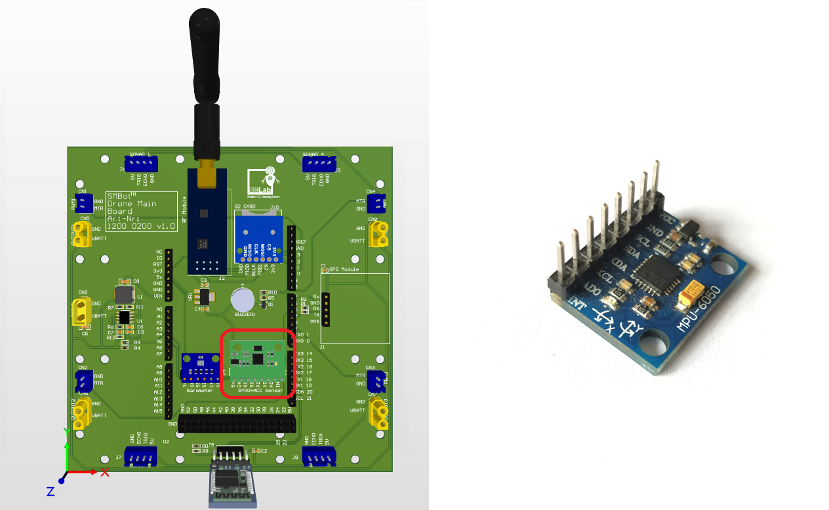Figure 26: MPU6050 module

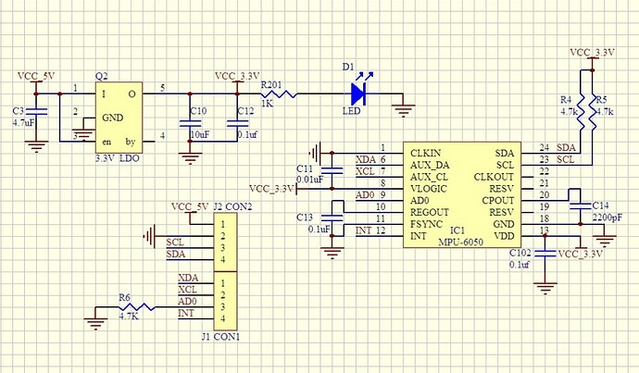Figure 27: Schematic of MPU6050 module

The following is the connection table between Arduino Uno and MPU6050 module

|  |  |
| --- | --- |
| Arduino | MPU6050 Module |
| 5v | Vcc |
| GND | GND |
| A5 | SCL |
| A4 | SDA |
| N.A. | XDA |
| N.A. | XCL |
| N.A. | AD0 |
| N.A. | INT |

Table 4: Connection table between Arduino UNO and MPU6050 Module

Vcc -> Power supply

GND -> Ground

SCK -> I2C msater serial clock

SDA -> I2C master serial data

XDA -> I2C master serial data, for connecting to external sensors

XCL -> I2C Master serial clock, for connecting to external sensors

AD0 -> I2C Slave Address LSB (AD0)

INT -> Interrupt digital output

We only able to communicate with MPU6050 through I2C communicatoin through pin A4 and A5. The slave address of the MPU-6050 is b110100X which is 7 bits long. The LSB bit os the 7 bit address is determined by the logic level of AD0. This allow two MPU-6050 to be connected to the same I2C bus. For Infonique drone we did not conncet to any signal , it will be logic low and the slave address of the MPU-6050 will be 0x68. Binary number system use a base of two (b1101000) while hexadecimal uses a base of 16 ( 0x68 ). To retrieve data from MPU6050 , we can import arduino library MPU6050_light. The details of MPU6050_light can refer to the following links: https://github.com/rfetick/MPU6050_light.

### 3.3.1 I2C communicaiton

I2C communicatoin is a goodway of adding complexity of features to your projects wihtou adding complexity of wiring. The I2C protocol is supported on all Arduino boards. It allows you to connect several peripheral devices, such as sensors , display and so on with only a few wire. Giving you lots of flexibility and speeding up your prototyping, without an abundancy of wires.

I2C protocl involves using two lines to send and receive data: a serial clock pin (SCL) that the arduino controlle rboard pulses at a regualr interval and a serial data pin (SDA) over which data is sent between the two devices. There is a master and one ore more slave devices connected to same I2C bus.

As the clock line changes from low to high, a single bit of information is transfered frmo master to the slave device over the SDA line. As the clock line keep pulsing, more and more bits are sent until a sequence of a 7 or 8 but address, and a command or data is formed. When this information is sent – bit after bit, the slave device will repy the data if needed to the master over the same line using the clock signal generated by the master device on the SCL as timing.

Each slave device in the I2C bus is functionally independent from the master, but will respond with information when prompted by the master. Hence every slave device will have it’s own unique address. In our case MPU6050 is 0x68 . In the conlcusion, I2C allowed Arduino Uno to communicate with many devices with only two pin of the arduino uno.

### 3.3.2 Skill activies of MPU6050

Objective : To experience how communicate with MPU6050

Tools : Arduino uno and Infonique Drone Board

Steps:

* Connect Infonique Drone Board to Ardruino uno
* Program the Arduino with the following code with Arduino IDE .
* Ensure Arduino IDE should have MPU6050_light.h library is installed.
* Try to change the orentation of the board , the accelertation of the X, Y and Z will change accordingly.

The following is the example code of communicate with MPU6050 module

#include "Wire.h"

#include <MPU6050_light.h>

byte bMPU6050  = 0;

MPU6050 mpu(Wire);

long mpu6050timer = 0;

void setup() {

  Wire.begin();

  /* Serial */

  Serial.begin(115200);

  Serial.println("Hello World!");

  bMPU6050 = mpu.begin();

  Serial.print(F("MPU6050 status: "));

  Serial.println(bMPU6050);

  if(0x00 == bMPU6050)

  {

    Serial.println(F("Calculating offsets, do not move MPU6050"));

  }

  delay(500);

  if(0x00 == bMPU6050)

  {

    mpu.calcOffsets(true,true); // gyro and accelero

    Serial.println("offset Done!\n");

  }

}

void loop() {

  if(0x00 == bMPU6050)

  {

    if(millis() - mpu6050timer > 1000)

    {

      mpu.update();

      Serial.print(F("TEMPERATURE: "));Serial.println(mpu.getTemp());

      Serial.print(F("ACCELERO  X: "));Serial.print(mpu.getAccX());

      Serial.print(" | Y: ");Serial.print(mpu.getAccY());

      Serial.print(" | Z: ");Serial.println(mpu.getAccZ());

      Serial.print(F("GYRO      X: "));Serial.print(mpu.getGyroX());

      Serial.print(" | Y: ");Serial.print(mpu.getGyroY());

      Serial.print(" | Z: ");Serial.println(mpu.getGyroZ());

      Serial.print(F("ACC ANGLE X: "));Serial.print(mpu.getAccAngleX());

      Serial.print(" | Y: ");Serial.println(mpu.getAccAngleY());

      Serial.print(F("ANGLE     X: "));Serial.print(mpu.getAngleX());

      Serial.print(" | Y: ");Serial.print(mpu.getAngleY());

      Serial.print(" | Z: ");Serial.println(mpu.getAngleZ());

      mpu6050timer = millis();

    }

  }

}

## 3.4 Barometer BMP280 module

There is a barometer in Infonique Drone which is BMP280 module. The following figure is showing the BMP80 module in the Infonique Drone.

Figure 28: BMP280 module

BMP280 is a enviromental sensor with temperature and barometric pressure. It can used to measure temperature and atmospehric pressure. It is able communication in SCA and SCL. For infonique Drone , we are communicate with BMP280 through I2C. BMP280 and MPU6050 is sharing the same I2C bus. The slave address of BMP280 is 0x77. The following is the schematic of the MPU6050 module

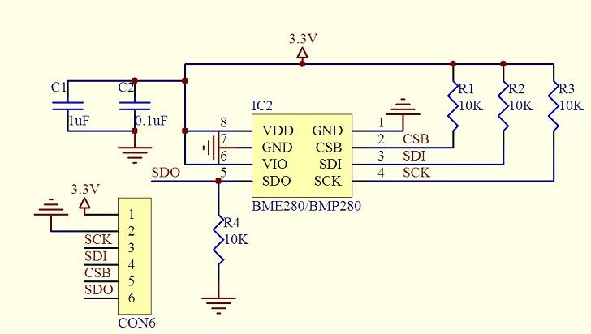Figure 29: Schematic of BMP280 module

The following is the connection table between Arduino Uno and BMP280 module

|  |  |
| --- | --- |
| Arduino | MPU6050 Module |
| 3v3 | Vcc |
| GND | GND |
| A5 | SCK |
| A4 | SDA |
| N.A. | CSB |
| N.A. | SDO |

Table 5: Connection table between Arduino UNO and BMP280 Module

Vcc -> Power

GND -> Ground

SCK -> Serial clock

SDA -> Serail Data

CSB -> GND to have SPI , 3v3 to have I2C. It is an input to the chop. By default I2C.

SDO -> If configure as SPI will act as Serial data output . If configure as I2C, connectiong to GND result slave address 0x76 or connecting to 3v3 result slave address as 0x77. Base on the schemativ above we can see that SDO is connection to 3v3. Hence the slave address BMP280 sensor for Infonique Drone is 0x77. We created the functino ourself by referencing the Adafruit_BMP280 library. The details of Adafruit_BMP280 can be refer to the following link: <https://github.com/adafruit/Adafruit_BMP280_Library>.

### 3.4.1 Skill activies of BMP280

Objective : To experience how communicate with MPU6050

Tools : Arduino uno and SMBot Drone Board

Steps:

* Connect SMBot Drone Board to Ardruino uno
* Program the Arduino with the following code with Arduino IDE .
* Check the temperature , humiditiy and pressure value from serial monitor.

The code will be slightly complicated since we interpret the data ourself instead of using library. From this activie , we can also notice that library can help us simplified our main code. However , libary will increase the code size because library is more general. By intrepret data ourself , the code size will be smaller since only required funciton are added. The following is the example code of communicate with BMP280 module.

#include <Wire.h>

#define BME280_ADDRESS 0x76

unsigned long int hum_raw,temp_raw,pres_raw;

signed long int t_fine;

uint16_t dig_T1;

int16_t dig_T2;

int16_t dig_T3;

uint16_t dig_P1;

int16_t dig_P2;

int16_t dig_P3;

int16_t dig_P4;

int16_t dig_P5;

int16_t dig_P6;

int16_t dig_P7;

int16_t dig_P8;

int16_t dig_P9;

int8_t  dig_H1;

int16_t dig_H2;

int8_t  dig_H3;

int16_t dig_H4;

int16_t dig_H5;

int8_t  dig_H6;

long BME280timer = 0;

void setup() {

  Wire.begin();

  /* Serial */

  Serial.begin(115200);

  Serial.println("Hello World!");

  uint8_t osrs_t = 1;             //Temperature oversampling x 1

  uint8_t osrs_p = 1;             //Pressure oversampling x 1

  uint8_t osrs_h = 1;             //Humidity oversampling x 1

  uint8_t mode = 3;               //Normal mode

  uint8_t t_sb = 5;               //Tstandby 1000ms

  uint8_t filter = 0;             //Filter off

  uint8_t spi3w_en = 0;           //3-wire SPI Disable

  uint8_t ctrl_meas_reg = (osrs_t << 5) | (osrs_p << 2) | mode;

  uint8_t config_reg    = (t_sb << 5) | (filter << 2) | spi3w_en;

  uint8_t ctrl_hum_reg  = osrs_h;

  Wire.begin();

  writeReg(0xF2,ctrl_hum_reg);

  writeReg(0xF4,ctrl_meas_reg);

  writeReg(0xF5,config_reg);

  readTrim();

}

void loop() {

  if(millis() - BME280timer > 1000)

  {

    double temp_act = 0.0, press_act = 0.0,hum_act=0.0;

    signed long int temp_cal;

    unsigned long int press_cal,hum_cal;

    readData();

    temp_cal = calibration_T(temp_raw);

    press_cal = calibration_P(pres_raw);

    hum_cal = calibration_H(hum_raw);

    temp_act = (double)temp_cal / 100.0;

    press_act = (double)press_cal / 100.0;

    hum_act = (double)hum_cal / 1024.0;

    Serial.print("TEMP : ");

    Serial.print(temp_act);

    Serial.print(" DegC  PRESS : ");

    Serial.print(press_act);

    Serial.print(" hPa  HUM : ");

    Serial.print(hum_act);

    Serial.println(" %");

    BME280timer = millis();

  }

}

void readTrim()

{

    uint8_t data[32],i=0;

    Wire.beginTransmission(BME280_ADDRESS);

    Wire.write(0x88);

    Wire.endTransmission();

    Wire.requestFrom(BME280_ADDRESS,24);

    while(Wire.available()){

        data[i] = Wire.read();

        i++;

    }

    Wire.beginTransmission(BME280_ADDRESS);

    Wire.write(0xA1);

    Wire.endTransmission();

    Wire.requestFrom(BME280_ADDRESS,1);

    data[i] = Wire.read();

    i++;

    Wire.beginTransmission(BME280_ADDRESS);

    Wire.write(0xE1);

    Wire.endTransmission();

    Wire.requestFrom(BME280_ADDRESS,7);

    while(Wire.available()){

        data[i] = Wire.read();

        i++;

    }

    dig_T1 = (data[1] << 8) | data[0];

    dig_T2 = (data[3] << 8) | data[2];

    dig_T3 = (data[5] << 8) | data[4];

    dig_P1 = (data[7] << 8) | data[6];

    dig_P2 = (data[9] << 8) | data[8];

    dig_P3 = (data[11]<< 8) | data[10];

    dig_P4 = (data[13]<< 8) | data[12];

    dig_P5 = (data[15]<< 8) | data[14];

    dig_P6 = (data[17]<< 8) | data[16];

    dig_P7 = (data[19]<< 8) | data[18];

    dig_P8 = (data[21]<< 8) | data[20];

    dig_P9 = (data[23]<< 8) | data[22];

    dig_H1 = data[24];

    dig_H2 = (data[26]<< 8) | data[25];

    dig_H3 = data[27];

    dig_H4 = (data[28]<< 4) | (0x0F & data[29]);

    dig_H5 = (data[30] << 4) | ((data[29] >> 4) & 0x0F);

    dig_H6 = data[31];

}

void writeReg(uint8_t reg_address, uint8_t data)

{

    Wire.beginTransmission(BME280_ADDRESS);

    Wire.write(reg_address);

    Wire.write(data);

    Wire.endTransmission();

}

void readData()

{

    int i = 0;

    uint32_t data[8];

    Wire.beginTransmission(BME280_ADDRESS);

    Wire.write(0xF7);

    Wire.endTransmission();

    Wire.requestFrom(BME280_ADDRESS,8);

    while(Wire.available()){

        data[i] = Wire.read();

        i++;

    }

    pres_raw = (data[0] << 12) | (data[1] << 4) | (data[2] >> 4);

    temp_raw = (data[3] << 12) | (data[4] << 4) | (data[5] >> 4);

    hum_raw  = (data[6] << 8) | data[7];

}

signed long int calibration_T(signed long int adc_T)

{

    signed long int var1, var2, T;

    var1 = ((((adc_T >> 3) - ((signed long int)dig_T1<<1))) * ((signed long int)dig_T2)) >> 11;

    var2 = (((((adc_T >> 4) - ((signed long int)dig_T1)) * ((adc_T>>4) - ((signed long int)dig_T1))) >> 12) * ((signed long int)dig_T3)) >> 14;

    t_fine = var1 + var2;

    T = (t_fine * 5 + 128) >> 8;

    return T;

}

unsigned long int calibration_P(signed long int adc_P)

{

    signed long int var1, var2;

    unsigned long int P;

    var1 = (((signed long int)t_fine)>>1) - (signed long int)64000;

    var2 = (((var1>>2) * (var1>>2)) >> 11) * ((signed long int)dig_P6);

    var2 = var2 + ((var1*((signed long int)dig_P5))<<1);

    var2 = (var2>>2)+(((signed long int)dig_P4)<<16);

    var1 = (((dig_P3 * (((var1>>2)*(var1>>2)) >> 13)) >>3) + ((((signed long int)dig_P2) * var1)>>1))>>18;

    var1 = ((((32768+var1))*((signed long int)dig_P1))>>15);

    if (var1 == 0)

    {

        return 0;

    }

    P = (((unsigned long int)(((signed long int)1048576)-adc_P)-(var2>>12)))*3125;

    if(P<0x80000000)

    {

       P = (P << 1) / ((unsigned long int) var1);

    }

    else

    {

        P = (P / (unsigned long int)var1) * 2;

    }

    var1 = (((signed long int)dig_P9) * ((signed long int)(((P>>3) * (P>>3))>>13)))>>12;

    var2 = (((signed long int)(P>>2)) * ((signed long int)dig_P8))>>13;

    P = (unsigned long int)((signed long int)P + ((var1 + var2 + dig_P7) >> 4));

    return P;

}

unsigned long int calibration_H(signed long int adc_H)

{

    signed long int v_x1;

    v_x1 = (t_fine - ((signed long int)76800));

    v_x1 = (((((adc_H << 14) -(((signed long int)dig_H4) << 20) - (((signed long int)dig_H5) * v_x1)) +

              ((signed long int)16384)) >> 15) * (((((((v_x1 * ((signed long int)dig_H6)) >> 10) *

              (((v_x1 * ((signed long int)dig_H3)) >> 11) + ((signed long int) 32768))) >> 10) + (( signed long int)2097152)) *

              ((signed long int) dig_H2) + 8192) >> 14));

   v_x1 = (v_x1 - (((((v_x1 >> 15) * (v_x1 >> 15)) >> 7) * ((signed long int)dig_H1)) >> 4));

   v_x1 = (v_x1 < 0 ? 0 : v_x1);

   v_x1 = (v_x1 > 419430400 ? 419430400 : v_x1);

   return (unsigned long int)(v_x1 >> 12);

}

## 3.4 GPS GT-U7 module

There is a GPS in Infonique Drone which is GT-U7 module. The following figure is showing the GT-U7 module in the Infonique Drone.

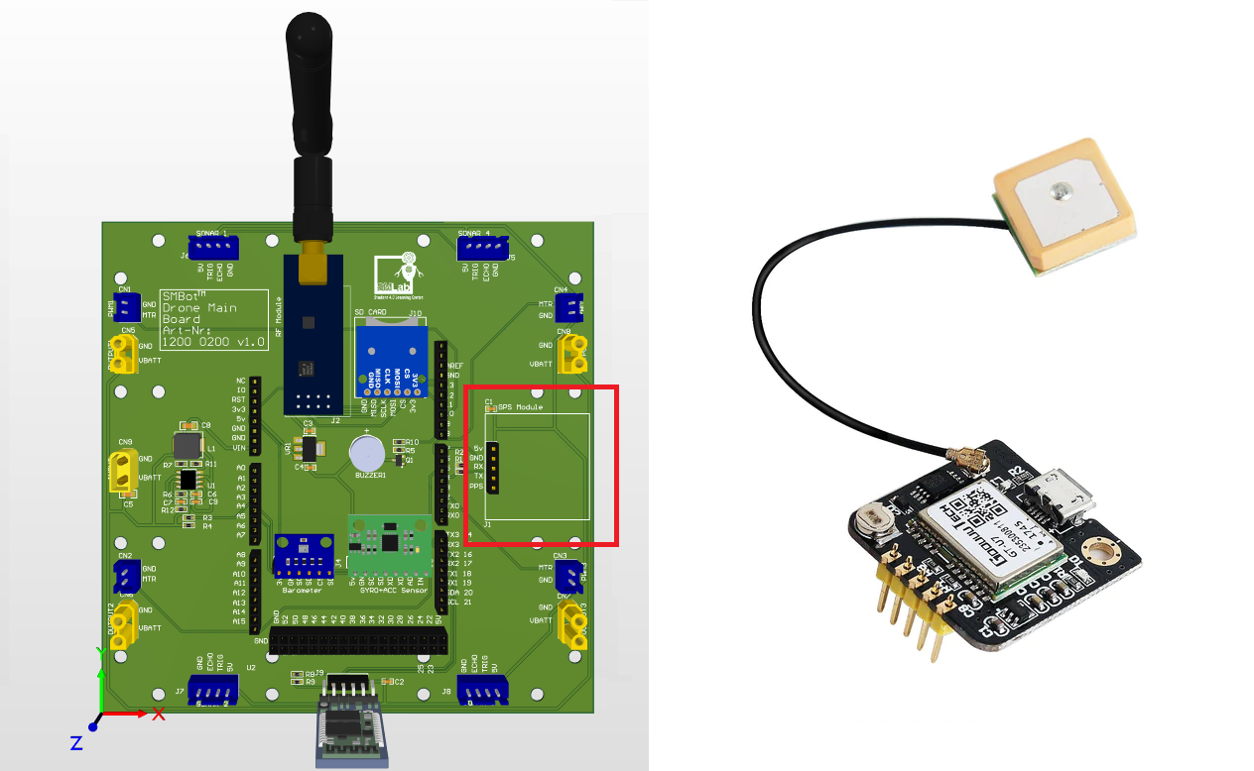Figure 30: GPS CT-U7 module

GT-U7 is a standalone GPS receivers. It is high sensitivity , low power consumption and miniaturisation. Its extremely high tracking sensitivity has greatly extended the positioning of the cover. It is using a IPEX antenna interface. We able to communicate with GT-U7 module with serial communication at baudrate 9600bps. The following is the connection table between Arduino Uno and GT-U7 module

|  |  |
| --- | --- |
| Arduino | MPU6050 Module |
| 5v | Vcc |
| GND | GND |
| D7 | Rx |
| D4 | Tx |
| N.A. | PPS |

Table 6: Connection table between Arduino UNO and GPS Module

Vcc -> Power

GND -> Ground

Rx -> Universal asynchronous receiver

Tx -> Universal asynchronous transmitter

PPS -> a pulse per second

### 3.4.1 Universal Asynchronous Receiver-Transmitter ( UART )

Universal Asynchronous Receiver-Transmitter (UART) is a serail communication protocol that can be used to esnd data between an arduino board and other devices. This is the protocol used when you sennd data from Arduino to your computer, using the classic Serial.print() method.

UART is one of the most used device-to-device (serial) communication protocols. It’s the protocol used by Arduino boards to communicate with the computer. It allows an asynchronous serial communication in which the data format and transmission speed are configurable. It's among the earliest serial protocols and even though it has in many places been replaced by SPI and I2C, it's still widely used for lower-speed and lower-throughput applications because it is very simple, low-cost and easy to implement.

UART operates by transmitting data as a series of bits, including a start bit, data bits, an optional parity bit, and stop bit(s). Unlike parallel communication, where multiple bits are transmitted simultaneously, UART sends data serially, one bit at a time. As the name reveals the protocol operates asynchronous which means that it doesn't rely on a shared clock signal. Instead, it uses predefined baud rates to determine the timing of data bits.

As seen in the image above when using parallel communication an 8-bit message would require eight cables while serial communication only requires one cable for sending messages and one for receiving.

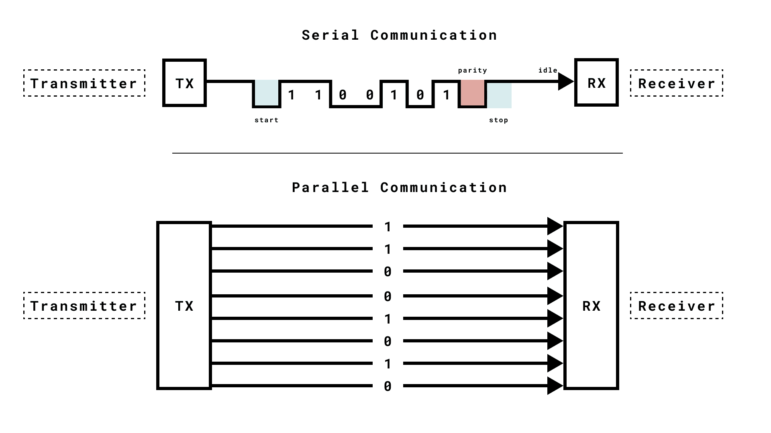Figure 31: Serial vs Parallel Communication

The key components of UART include the transmitter, receiver, and baud rate. The transmitter collects data from a source, formats it into serial bits, and sends it via a TX (Transmit) pin. The receiver receives it via a RX (Receive) pin, processes incoming serial data and converts it into parallel data for the host system. The baud rate determines the speed of data transmission. It is asyncrhnous because it doesn’t rely on a shared clock signal to coordinate data transmission

### 3.4.2 NEMA-0183

The GT-U7 is following NEMA-0183 (National Marine Electronics Association ) standard.

|  |  |
| --- | --- |
| Sentence | Description |
| $Talker ID+GGA | Global Positioning System Fixed Data |
| $Talker ID+GLL | Geographic Position-- Latitude and Longitude |
| $Talker ID+GSA | GNSS DOP and active satellites |
| $Talker ID+GSV | GNSS satellites in view |

Table 7: NEMA-0183 message

Hence we can interpret the data base on the standard and retrieve the data that we are interested which are GGA $GPGGA,181908.00,3404.7041778,N,07044.3966270,W,4,13,1.00,495.144,M,29.200,M,0.10,0000,*40

|  |  |
| --- | --- |
| GP | **GPS position** |
| **181908.00** | **timestamp** (UTC in hours, minutes, and seconds). |
| **3404.7041778** | **latitude** in DDMM.MMMMM format. |
| **N** | **north latitude** |
| **07044.3966270** | **longitude** in DDDMM.MMMMM format. |
| **W** | **west longitude**. |
| **4** | **quality indicator** (precision). |
| **13** | **number of satellites** used to define the coordinate. |
| **1.00** | **horizontal dilution of precision** (HDOP). |
| **495.144** | **altitude of the GPS antenna**. |
| **M** | **unit of altitude** (meters or feet). |
| **29.200** | **geoidal separation**. |
| **M** | **unit of the geoidal separation** (meters or feet). |
| **1.0** | **age of the correction** |
| **0000** | **correction station ID** (if any).  **checksum**. |
| **\*40** |  |

Table 8: Interpretion of GGA

.

### 3.4.3 Skill activities on GT-U7 module

Objective : To experience how communicate with GT-U7

Tools : Arduino uno and SMBot Drone Controller Board

Steps:

* Connect SMBot Drone Board to Ardruino uno
* Program the Arduino with the following code with Arduino IDE .
* Ensure Arduino IDE should have TinyGPS.h library is installed.
* Retrieve the latitude and longtitude of from the serial monitor and confirm it with google map. It should show your current location. If indoor dont have GPS signal, please try at outdoor.

The following is the example code of communicate with GT-U7 module.

#include <TinyGPS.h>

#include <SoftwareSerial.h>

/* Pinout Definition */

#define gpsTx 7

#define gpsRx 4

/*GPS*/

TinyGPS gps;

SoftwareSerial mySerial(4,7);

long gpstimer = 0;

bool newData = false;

unsigned long chars;

unsigned short sentences, failed;

void setup() {

  /* Serial */

  Serial.begin(115200);

  Serial.println("Hello World!");

  mySerial.begin(9600);

}

void loop() {

    while (mySerial.available())

  {

      char c = mySerial.read();

      Serial.write(c); // uncomment this line if you want to see the GPS data flowing

      if (gps.encode(c)) // Did a new valid sentence come in?

        newData = true;

  }

  if(millis() - gpstimer > 1000) // print data every second

  {

    if (newData)

    {

      newData = false;

      float flat, flon;

      unsigned long age;

      gps.f_get_position(&flat, &flon, &age);

      Serial.print("LAT=");

      Serial.print(flat == TinyGPS::GPS_INVALID_F_ANGLE ? 0.0 : flat, 6);

      Serial.print(" LON=");

      Serial.print(flon == TinyGPS::GPS_INVALID_F_ANGLE ? 0.0 : flon, 6);

      Serial.print(" SAT=");

      Serial.print(gps.satellites() == TinyGPS::GPS_INVALID_SATELLITES ? 0 : gps.satellites());

      Serial.print(" PREC=");

      Serial.println(gps.hdop() == TinyGPS::GPS_INVALID_HDOP ? 0 : gps.hdop());

    }

    gpstimer = millis();

  }

}

3.5 SD card connector

There is a SD card module on Infonique Drone .The following figure is showing the SD card module in the Infonique Drone.

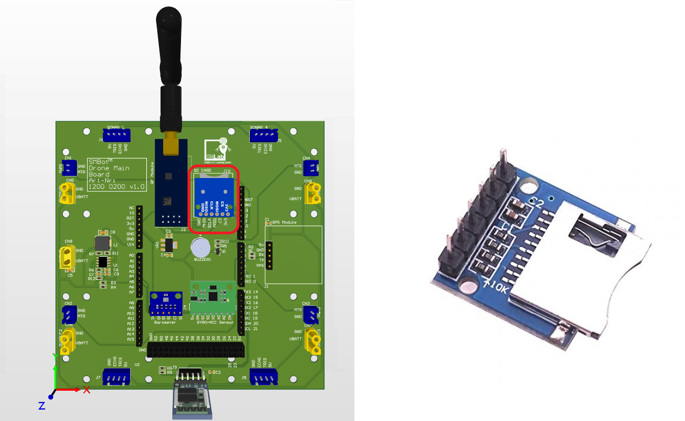Figure 32: SD Card module

The Sd card module is useful for projects that require data logging. Arduino can create a file in SD card to write and save data using the SD library. SD card module is communicate through SPI. It sharing the same SPI bus with Wireless Radio frequency module. As we disccussed in the previous chapter there is able ot have multiple slave device in a same SPI bus with differrent chip select pins. The following is the connection table between Arduino Uno and GT-U7 module

|  |  |
| --- | --- |
| Arduino | MPU6050 Module |
| 5v | Vcc |
| D2 | CS |
| D11 | MOSI |
| D13 | CLK |
| D12. | MISO |
| GND | GND |

Table 9: Connection table between Arduino UNO and SD card Module

### 3.5.1 Skill activities on SD Card module

Objective : To experience how communicate with SD Card

Tools : Arduino uno and SMBot Drone Controller Board

Steps:

* Connect SMBot Drone Controller Board to Ardruino uno
* Program the Arduino with the following code with Arduino IDE .
* Ensure Arduino IDE should have SD.h library is installed.
* Open with SD card reader and check whehter the test.txt is created.

The following is the example code of communicate with GT-U7 module.

#include <SPI.h>

#include <SD.h>

/* Pinout Definition */

#define sdCSPin 2

File myFile;

void setup() {

  // Open serial communications and wait for port to open:

  Serial.begin(9600);

  while (!Serial) {

    ; // wait for serial port to connect. Needed for native USB port only

  }

  Serial.print("Initializing SD card...");

  if (!SD.begin(sdCSPin)) {

    Serial.println("initialization failed!");

    while (1);

  }

  Serial.println("initialization done.");

  // open the file. note that only one file can be open at a time,

  // so you have to close this one before opening another.

  myFile = SD.open("test.txt", FILE_WRITE);

  // if the file opened okay, write to it:

  if (myFile) {

    Serial.print("Writing to test.txt...");

    myFile.println("testing 1, 2, 3.");

    // close the file:

    myFile.close();

    Serial.println("done.");

  } else {

    // if the file didn't open, print an error:

    Serial.println("error opening test.txt");

  }

  // re-open the file for reading:

  myFile = SD.open("test.txt");

  if (myFile) {

    Serial.println("test.txt:");

    // read from the file until there's nothing else in it:

    while (myFile.available()) {

      Serial.write(myFile.read());

    }

    // close the file:

    myFile.close();

  } else {

    // if the file didn't open, print an error:

    Serial.println("error opening test.txt");

  }

}

void loop() {

  // nothing happens after setup

}

3.6 Battery

Infonique Drone is using lithium battery. Lithium battery is the battery that currently using in the Electric Vehicle. Lithium battery is better than those traditional battery technology. It able to charge faster, last longer and have a higher power density for more battery life in a lighter package. The following figure is the lithium battery that used by Infonique Drone

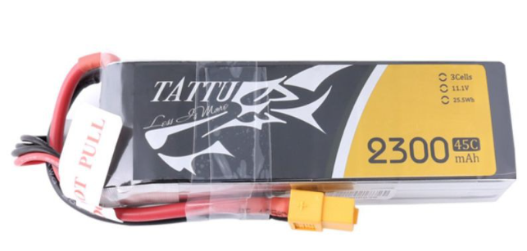Figure 33: 3S lithium battery

There few parameter to understand the lithium battery which are discharge rating , capacity and cell count. The lithium battery used by Infonique drone is a 3S lithium battery which mean there are 3 cells connected in series in the lithium battery . Each lithium cell is rated at 3.7v hence 3s mean nominal volatge will be at 11.1v. When fully charge , lithium battery will be at 4.2v which are 12.6v. Capacity is the measure of how much power the battery can hold. The unit of measure is milliamp hours. For the battery shown in figure above it is 2300mAh which mean it can supply at 2300 mA for an hour maximum. The discharge rating is a measure of how fast the batter can discharged safely without harming the battery.For the battery shown in figure above it is 45C which mean it can suppy 45 x 2.3A = 103.5A is the maximum current that the battery can supply at a time. Going higher than this might result degradation of battery or worst it will burst into flames. Please be extra caution when dealing with battery , it may caught fire. We can see the clip show in the youtube <https://www.youtube.com/watch?v=HCGtRgBUHX8&ab_channel=afisher619>

For a lithium battery it will caught fire when we over charge it . Since the battery that use in infonique drone is connected in series . We suggest to charge the battery with battery charger to avoid disaster. This can ensure each cell of the lithium battery will not be overcharge , cause the battery charger will take care the voltage of each cell load.

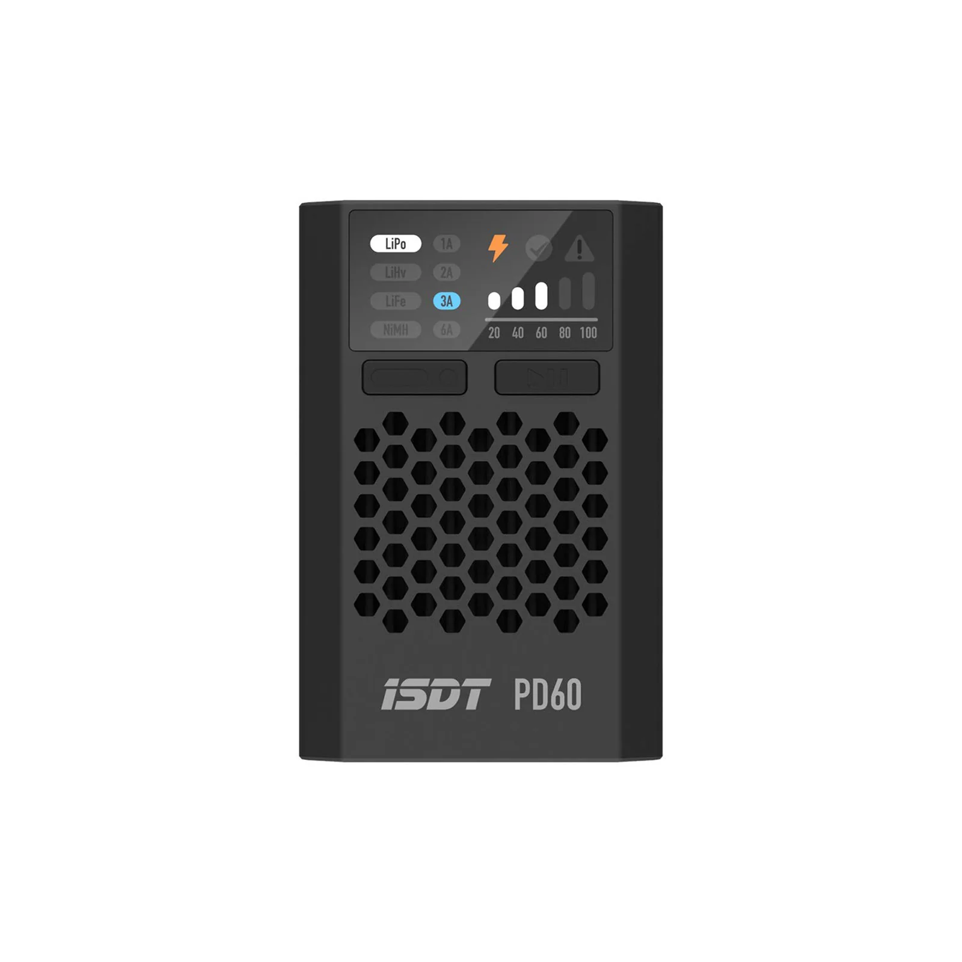Figure 34: Battery charger

The battery voltage can reach 12.4v at fully charge which is exceeded the limit of arduino uno pinout. It will fry the board. Hence we need to use voltage divider rule for the battery voltage measuring circuit.Infonique drone is using pin A3 to measure battery voltage.The following figure is the battery voltage measuring circuit.

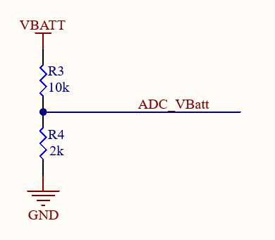Figure 35: Battery voltage measuring circuit

Arduino uno Adc channels can read 0 to 5v. It is a 10bit ADC which means it will give digital value in the rang of 0 – 1023. Hence the formula to retreive the battery voltage of Infonique drone will be battery volatege = ((((adc value * 5 )/1023) * 12) / 2).

3.6.1 Skill activities on SD Card module

Objective : To experience how communicate with SD Card

Tools : Mulimeter,Battery,Arduino uno and SMBot Drone Board

Steps:

* Measure the battery voltage
* Connect SMBot Drone Board to Ardruino uno
* Coneect the battery to SMBot Drone board
* Program the Arduino with the following code with Arduino IDE .
* Observe compare the voltage display in the serial monitor

The following is the example code of measuring battery voltage

#define batteryVoltagePin A3

/* adcVoltage*/

long adcTimer = 1000;

void setup() {

  // put your setup code here, to run once:

  Serial.begin(115200);

  Serial.write("Hello World\n");

}

void loop() {

  if(millis() - adcTimer > 1000) // print data every second

  {

    float voltage = analogRead(batteryVoltagePin);

    Serial.print("voltage : ");

    Serial.print(((voltage)*5/1023)*12/2);

    Serial.println("v");

    adcTimer = millis();

  }

}

3.7 Bluetooth module HC-05 module

Infonique drone support bluetooth communication with HC-05 module but it only available when uasing with arduino mega. This is due to the arduino uno only have limited pinout. The figure following is showing the HC-05 connector and HC-05 module.

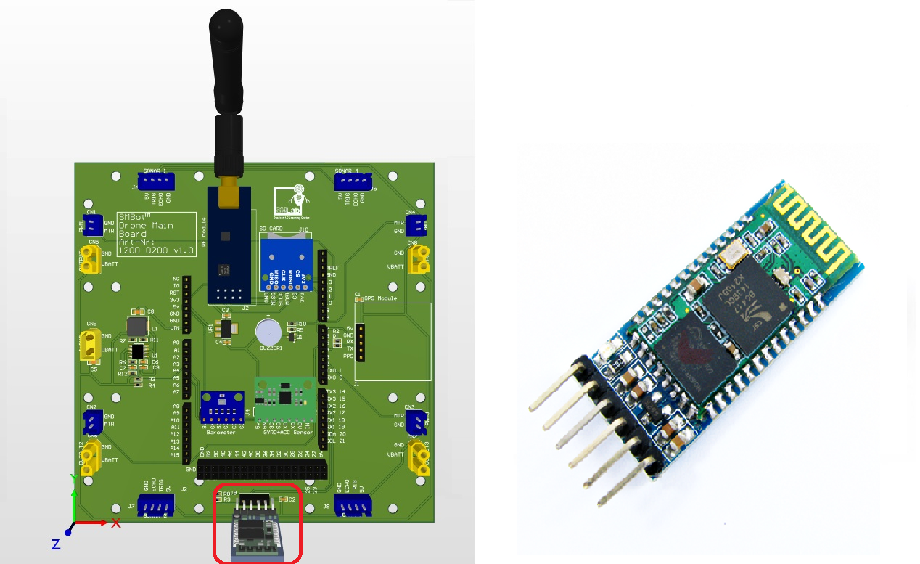Figure 36: Hc-05 connector and HC-05 module

It is used for many applications like wireless headset, game controllers, wireless mouse, wireless keyboard, and many more consumer applications.It has range up to <100m which depends upon transmitter and receiver, atmosphere, geographic & urban conditions. It is IEEE 802.15.1 standardized protocol, through which one can build wireless Personal Area Network (PAN). It uses frequency-hopping spread spectrum (FHSS) radio technology to send data over air.It uses serial communication to communicate with devices. It communicates with microcontroller using serial port (USART).The following is the connection table between Arduino Mega and HC-05 module

|  |  |
| --- | --- |
| Arduino | MPU6050 Module |
| N.A. | State |
| D14 | RXD |
| D15 | TXD |
| GND | GND |
| 5v | VCC |
| N.A. | EN |

Table 10: Connection table between Arduino UNO and SD card Module

STATE -> It tells whether module is connected or not

RXD -> Universal asynchronous receiver

TXD -> Universal asynchronous transmitter

GND -> Ground

Vss -> 5v

En -> By default Data mode , logic high will be Command mode

Data modde -> Exchange of data between devices

Command mode -> Update the setting of HC-05 module with AT commands,

### 3.8.1 Skill activities for HC-05

Objective : To experience the communication between bluetooth module and andoird phone

Tools : Phone,HC-05 , Arduino MEGA and SMBot Drone Board

Steps:

* Connect SMBot Drone Board to Ardruino uno
* Coneect the HC-05 to SMBot Drone board
* Program the Arduino with the following code with Arduino IDE .
* Ensure you phone with bluetooth communication app such as Arduino Bluetooth Controller.
* Your phone will be send text to arduino MEGA and display at the serial monitor.

The following is the example code of measuring distance with HC-05

#include <SoftwareSerial.h>

/* Pinout Definition */

#define bluetoothTx 14

#define bluetoothRx 15

/*bluetooth*/

SoftwareSerial mySerial(bluetoothRx,bluetoothTx); // RX, TX

void setup() {

  // put your setup code here, to run once:

  Serial.begin(9600);

  mySerial.begin(9600);

  Serial.write("Hello World\n");

}

void loop() {

  // put your main code here, to run repeatedly:

  delay(1);

  bluetooth();

}

void bluetooth()

{

  if (mySerial.available()) {

    Serial.print("bluetooth :");

    Serial.write(mySerial.read());

    Serial.println();

  }

}

3.8 Ultrasonic sensor HC-SR04 module

Infonique drone support 4 HC-SR04 module but it only available when uasing with arduino mega. This is due to the arduino uno only have limited pinout. The figure following is showing the HC-SR04 connector and HC-SR04 module.

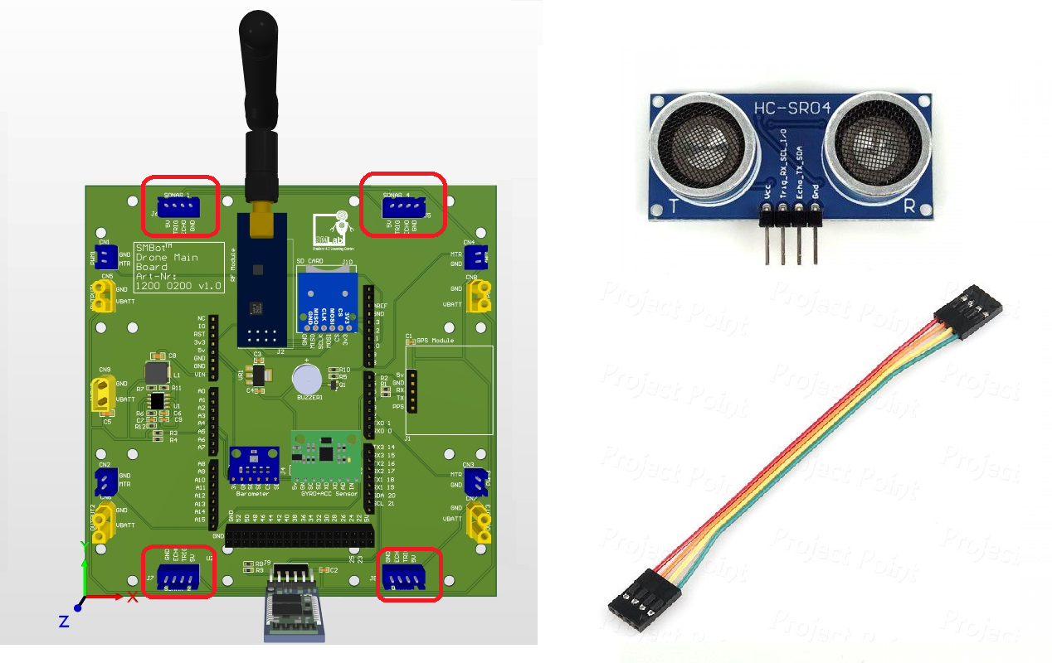Figure 37: HC-SR04 connector and module

HC-SR04 is an ultrasonic distance sensor. It is an economical sensor provides 2cm to 400cm of non-contact measurement functionality with a ranging accuracy that can reach up to 3mm. Each HC-SR04 module includes an ultrasonic transmitter, a receiver and a control circuit.The following is the connection table between Arduino Mega and GT-U7 module

|  |  |
| --- | --- |
| Arduino | MPU6050 Module |
| 5v | Vcc for all 4 modules |
| A2 | Trigger for all 4 modules |
| A6 | Echo for module 1 |
| A7 | Echo for module 2 |
| A8 | Echo for module 3 |
| A9 | Echo for module 4 |
| GND | GND for all 4 modules |

Table 11: Connection table between Arduino UNO and SD card Module

### 3.8.1 Skill activities for HC-SR04

Objective : To experience how measure distance with HC-SR04

Tools : Ruler,HC-SR04 , Arduino MEGA and SMBot Drone Board

Steps:

* Connect SMBot Drone Board to Ardruino uno
* Coneect the HC-SR04 to SMBot Drone board
* Program the Arduino with the following code with Arduino IDE .
* Put your hand ( any object ) infront of the HC-SR04 , the distance display on the serial monitor should be same as the distance between your hand and HC-SR04

The following is the example code of measuring distance with HC-SR04

/* Pinout Definition */

#define triggerPin A2

#define echoPin  A6

/* UltrasonicSensor */

int ultrasonicSensorTimeout = 0;

void setup() {

  // put your setup code here, to run once:

  Serial.begin(9600);

  Serial.write("Hello World\n");

}

void loop() {

  // put your main code here, to run repeatedly:

  delay(1);

  ultrasonicSensor();

}

void ultrasonicSensor(){

  if(0!= ultrasonicSensorTimeout){

    ultrasonicSensorTimeout--;

  }

  else{

    ultrasonicSensorTimeout = 1000;

    ultrasonicSensor();

    float duration, distance;

    pinMode(triggerPin, OUTPUT);

    digitalWrite(triggerPin, LOW);

    delayMicroseconds(2);

    digitalWrite(triggerPin, HIGH);

    delayMicroseconds(10);

    digitalWrite(triggerPin, LOW);

    pinMode(echoPin, INPUT);

    duration = pulseIn(echoPin, HIGH);

    distance = (duration*.0343)/2;

    Serial.print("Distance : ");

    Serial.print(distance);

    Serial.print("cm");

    Serial.println();

  }

}